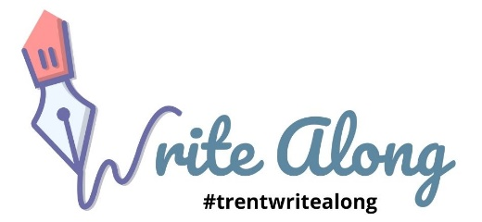CHECKLIST: REVISING THE PAPER

Argument & Organization
- Is the topic focused and narrow?
- Does the topic fulfill the assignment’s requirements and the expectations of the instructor?
- Is the thesis of your essay clear, and is it stated precisely?
- Have you provided sufficient and accurate evidence and explained how it supports the thesis?
- Is your essay clearly and logically organized?
- Are there any gaps or irrelevant ideas that need to be addressed?
- Have you used transitions to show the relations between the major points you are making?
- Have you revised this work with consideration of feedback you have received on previous work?

Clarity & Grammar
- Have you used language that is clear and easy to understand?
- Have you avoided slang and jargon? Are your words too informal? Are they overly-elaborate?
- Is your language as concise as possible? Have you eliminated repetition and unnecessary words?
- Have you avoided run-on sentences and comma splices? Have you avoided sentence fragments?
- Have you used the period, semi-colon, colon, dash and comma correctly?
- Have you capitalized the words that should be?
- Have you read your work slowly and systematically (reading aloud works) to edit your common grammatical and stylistic errors?

Format & Referencing
- Have you quoted properly and introduced your quotations using the correct punctuation?
- Do you cite all of your sources using an acceptable style, and do you stick to this style consistently throughout?
- Do you list all of the sources you cited in a references list conforming to the citation style used throughout?
- Does your title page or first page contain all the information your instructor needs?

